Lab No. 04
Custom Vector Class

Lab Tasks
Create a new file called MyVector.cpp (or main.cpp). Write the MyVector class at the top, then complete each task inside main(). Compile and run after each task.
g++ MyVector.cpp -o MyVector (compile)
./MyVector (run)

Task 1: Write the Class + Constructor + Destructor

#include <iostream>
using namespace std;
class MyVector {
private:
int* arr;
int size;
int capacity;
public:
// ---------- Task 1: implement these ----------
MyVector() {
// TODO: set capacity = 2, size = 0
// TODO: allocate arr with new int[capacity]
~MyVector() {
}
int getSize() { return size; }
int getCapacity(){ return capacity; }
bool isEmpty() { return size == 0; }
// ---------- Tasks 2-6: fill these in ----------
void push_back(int value) { }
void pop_back() { }
int get(int index) { return -1; }
void set(int index, int value) { }
void insert(int index, int value) { }
void erase(int index) { }
void display() { }
int main() {
MyVector v;
cout << "Size: " << v.getSize() << endl;
cout << "Capacity: " << v.getCapacity() << endl;
cout << "Empty? " << v.isEmpty() << endl;
return 0;
}

Expected Output:
Size: 0
Capacity: 2
Empty? 1
Output:
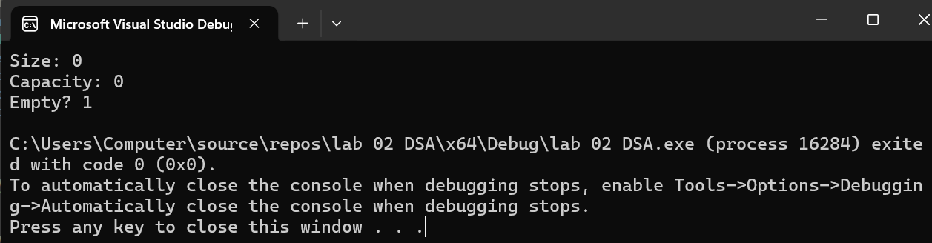

Task 2: Implement push_back and display
What to Implement push_back(int value) — if full, double capacity and copy; then store value at arr[size] and increment size 2. display() — loop from 0 to size-1 and print each element separated by spaces
display() Hint
void display() {
cout << "Vector: ";
for (int i = 0; i < size; i++)
cout << arr[i] << " ";
cout << endl;
}
Test This in main()
MyVector v;
v.push_back(10);
v.push_back(20);
v.push_back(30);
v.push_back(40);
v.display();
cout << "Size: " << v.getSize() << endl;
cout << "Capacity: " << v.getCapacity() << endl;

Expected Output:
Vector: 10 20 30 40
Size: 4
Capacity: 4

Code:
#include <iostream>
using namespace std;
class MyVector {
private:
int* arr;
int size;
int capacity;
public:
MyVector() {
capacity = 2;
size = 0;
arr = new int[capacity];
}
void push_back(int value) {
if (size == capacity) {
capacity = capacity * 2;
int* temp = new int[capacity];
for (int i = 0; i < size; i++) {
temp[i] = arr[i];
}
arr = temp;
}
arr[size] = value;
size++;
}
void display() {
cout << "Vector ";
for (int i = 0; i < size; i++)
cout << arr[i] << " ";
cout << endl;
}
int getSize() {
return size;
}
int getCapacity() {
return capacity;
}
};
int main() {
MyVector v;
v.push_back(10);
v.push_back(20);
v.push_back(30);
v.push_back(40);
v.display();
cout << "Size " << v.getSize() << endl;
cout << "Capacity" << v.getCapacity() << endl;
return 0;
}
Output:
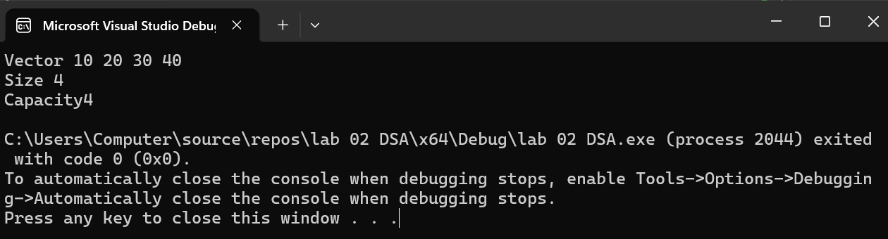

Task 3: Implement get and set

Implement get (read one element by index) and set (change one element by index). These work just like reading and writing an array slot. What to Implement get(int index) — return arr[index]. If index is out of range (< 0 or >= size), print an error message and return -1. set(int index, int value) — store value into arr[index]. Check range first.
get() Hint
int get(int index) {
if (index < 0 || index >= size) {
cout << "Error: index out of range" << endl;
return -1;
}
return arr[index];
}
Test This in main()
MyVector v;
v.push_back(10);
v.push_back(20);
v.push_back(30);
cout << v.get(0) << endl; // first element
cout << v.get(2) << endl; // last element
v.set(1, 99); // change middle element
v.display();
v.get(5); // out of range

Expected Output:
10
30
Vector: 10 99 30
Error: index out of range

Code:
#include <iostream>
using namespace std;
class MyVector {
private:
int* arr;
int size;
int capacity;
public:
MyVector() {
capacity = 2;
size = 0;
arr = new int[capacity];
}
void push_back(int value) {
if (size == capacity) {
capacity = capacity * 2;
int* temp = new int[capacity];
for (int i = 0; i < size; i++) {
temp[i] = arr[i];
}
delete[] arr;
arr = temp;
}
arr[size] = value;
size++;
}
void display() {
cout << "Vector: ";
for (int i = 0; i < size; i++)
cout << arr[i] << " ";
cout << endl;
}
int get(int index) {
if (index < 0 || index >= size) {
cout << "Error: index out of range" << endl;
return -1;
}
return arr[index];
}
void set(int index, int value) {
if (index < 0 || index >= size) {
cout << "Error: index out of range" << endl;
return;
}
arr[index] = value;
}
int getSize() {
return size;
}
int getCapacity() {
return capacity;
}
};
int main() {
MyVector v;
v.push_back(10);
v.push_back(20);
v.push_back(30);
cout << v.get(0) << endl;
cout << v.get(2) << endl;
v.set(1, 99);
v.display();
v.get(5);
return 0;
}
Output:
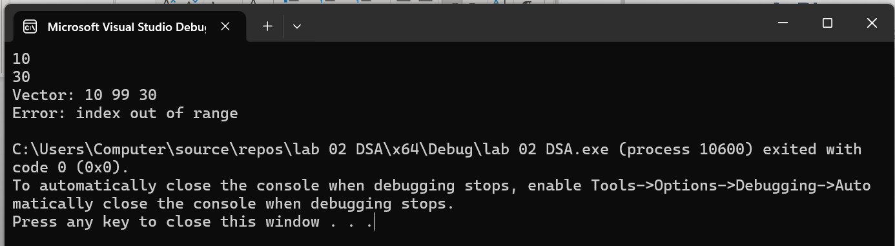

Task 4: Implement pop_back
pop_back removes the last element. This is the simplest of all operations — you do not need to move any elements or free memory. Simply decrease size by 1. But first check that the vector is not already empty.What to Implement pop_back() — if size is 0, print an error. Otherwise just do size--.
pop_back() Hint
void pop_back() {
if (size == 0) {
cout << "Error: vector is empty" << endl;
return;
}
size--;
}
Test This in main()
MyVector v;
v.push_back(10);
v.push_back(20);
v.push_back(30);
v.display();
v.pop_back();
v.display();
v.pop_back();
v.pop_back();
v.pop_back(); // try on empty vector

Expected Output:
Vector: 10 20 30
Vector: 10 20
Error: vector is empty
Code:
#include <iostream>
using namespace std;
class MyVector {
private:
int* arr;
int size;
int capacity;
public:
MyVector() {
capacity = 2;
size = 0;
arr = new int[capacity];
}
void push_back(int value) {
if (size == capacity) {
capacity = capacity * 2;
int* temp = new int[capacity];

for (int i = 0; i < size; i++) {
temp[i] = arr[i];
}
arr = temp;
}
arr[size] = value;
size++;
}
void pop_back() {
if (size == 0) {
cout << "Error: vector is empty" << endl;
return;
}
size--;
}
void display() {
cout << "Vector";
for (int i = 0; i < size; i++)
cout << arr[i] << " ";
cout << endl;
}

int getSize() {
return size;
}

int getCapacity() {
return capacity;
}
};

int main() {
MyVector v;
v.push_back(10);
v.push_back(20);
v.push_back(30);
v.display();
v.pop_back();
v.display();
v.pop_back();
v.pop_back();
v.pop_back();

return 0;
}
Output:
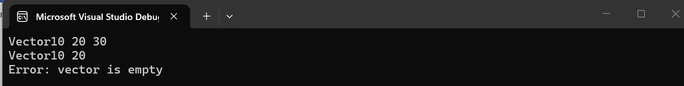

Task 5: Implement insert
insert adds a new element at a given position. To make room, every element from that position onwards must be shifted one step to the right. You must shift from right to left — shifting left to right would overwrite elements before they are moved.
Step-by-Step Algorithm Check if the vector is full. If so, double capacity (same as push_back). Check that index is valid (0 to size inclusive). Starting from the END, shift each element one position right until you reach index. Place the new value at arr[index]. Increment size.
Shift Diagram — inserting 99 at index 1
Before: [ 10 ][ 20 ][ 30 ][ ]
^ shift from here
Step 1: [ 10 ][ 20 ][ 30 ][ 30 ] (copy index 2 to index 3)
Step 2: [ 10 ][ 20 ][ 20 ][ 30 ] (copy index 1 to index 2)
Insert: [ 10 ][ 99 ][ 20 ][ 30 ] (place 99 at index 1)
Test This in main()
MyVector v;
v.push_back(10);
v.push_back(20);
v.push_back(30);
v.display();
v.insert(1, 99); // insert 99 at position 1
v.display();
v.insert(0, 5); // insert 5 at the front
v.display();

Expected Output:
Vector: 10 20 30
Vector: 10 99 20 30
Vector: 5 10 99 20 30

Code:
#include <iostream>
using namespace std;
class MyVector {
private:
int* arr;
int size;
int capacity;
public:
MyVector() {
capacity = 2;
size = 0;
arr = new int[capacity];
}
void push_back(int value) {
if (size == capacity) {
capacity = capacity * 2;
int* temp = new int[capacity];
for (int i = 0; i < size; i++)
temp[i] = arr[i];
delete[] arr;
arr = temp;
}
arr[size] = value;
size++;
}
void insert(int index, int value) {
if (size == capacity) {
capacity = capacity * 2;
int* temp = new int[capacity];
for (int i = 0; i < size; i++)
temp[i] = arr[i];
delete[] arr;
arr = temp;
}
if (index < 0 || index > size) {
cout << "Error: invalid index" << endl;
return;
}
for (int i = size; i > index; i--)
arr[i] = arr[i - 1];

arr[index] = value;
size++;
}
void display() {
cout << "Vector: ";
for (int i = 0; i < size; i++)
cout << arr[i] << " ";
cout << endl;
}
};
int main() {
MyVector v;
v.push_back(10);
v.push_back(20);
v.push_back(30);
v.display();
v.insert(1, 99);
v.display();
v.insert(0, 5);
v.display();

return 0;
}
Output:
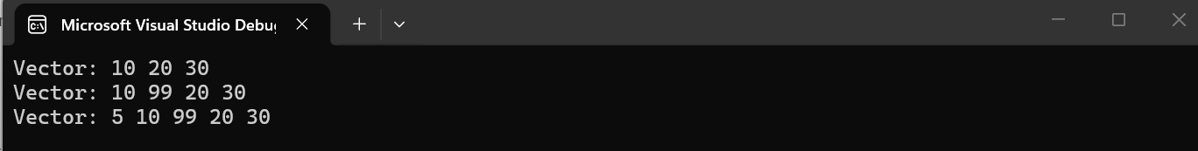

Task 6: Implement erase
erase removes the element at a given index. Every element after it must shift one position to the left to fill the gap. This is the opposite of insert — shift left to right.
Step-by-Step Algorithm
- Check that index is valid (0 to size-1).
- Starting from index, copy arr[i+1] into arr[i] for each position until the end.
- Decrement size.
Shift Diagram — erasing index 1
Before: [ 10 ][ 99 ][ 20 ][ 30 ]
^ erase this
Step 1: [ 10 ][ 20 ][ 20 ][ 30 ] (copy index 2 to index 1)
Step 2: [ 10 ][ 20 ][ 30 ][ 30 ] (copy index 3 to index 2)
Result: [ 10 ][ 20 ][ 30 ] size = 3
Test This in main()
MyVector v;
v.push_back(10);
v.push_back(20);
v.push_back(30);
v.push_back(40);
v.display();
v.erase(1); // remove element at index 1 (value 20)
v.display();
v.erase(0); // remove first element
v.display();

Expected Output:
Vector: 10 20 30 40
Vector: 10 30 40
Vector: 30 40
Code:
#include <iostream>
using namespace std;
class MyVector {
private:
int* arr;
int size;
int capacity;
public:
MyVector() {
capacity = 2;
size = 0;
arr = new int[capacity];
}
void push_back(int value) {
if (size == capacity) {
capacity = capacity * 2;
int* temp = new int[capacity];
for (int i = 0; i < size; i++)
temp[i] = arr[i];
delete[] arr;
arr = temp;
}
arr[size] = value;
size++;
}
void erase(int index) {
if (index < 0 || index >= size) {
cout << "Error: invalid index" << endl;
return;
}
for (int i = index; i < size - 1; i++)
arr[i] = arr[i + 1];
size--;
}
void display() {
cout << "Vector: ";
for (int i = 0; i < size; i++)
cout << arr[i] << " ";
cout << endl;
}
};
int main() {
MyVector v;
v.push_back(10);
v.push_back(20);
v.push_back(30);
v.push_back(40);
v.display();
v.erase(1);
v.display();
v.erase(0);
v.display();
return 0;
}
Output:
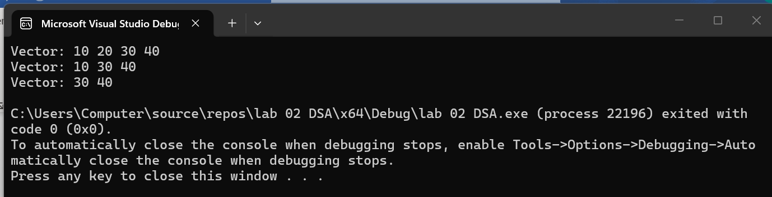

Task 7: Final Practice — Putting It All Together
Now use your complete MyVector class to solve the following exercises. Write each one separately in main() and verify your output matches.
Exercise A — Build and Modify a List
Create a vector, add numbers 1 through 6, then perform the following operations in order and display the result after each step: Display the original vector. Insert the value 99 at index 2. Remove the element at index 4. Change the last element to 0 using set. Display the final vector and its size
Expected Output:
Vector: 1 2 3 4 5 6
Vector: 1 2 99 3 4 5 6
Vector: 1 2 99 3 5 6
Vector: 1 2 99 3 5 0
Size: 6
Code:
#include <iostream>
using namespace std;
class MyVector {
private:
int* arr;
int size;
int capacity;
public:
MyVector() {
capacity = 2;
size = 0;
arr = new int[capacity];
}
void push_back(int value) {
if (size == capacity) {
capacity *= 2;
int* newArr = new int[capacity];
for (int i = 0; i < size; i++) {
newArr[i] = arr[i];
}
delete[] arr;
arr = newArr;
}
arr[size] = value;
size++;
}
void insert(int index, int value) {
if (index < 0 || index > size) {
return;
}
if (size == capacity) {
capacity *= 2;
int* newArr = new int[capacity];
for (int i = 0; i < size; i++) {
newArr[i] = arr[i];
}
delete[] arr;
arr = newArr;
}
for (int i = size; i > index; i--) {
arr[i] = arr[i - 1];
}
arr[index] = value;
size++;
}
void erase(int index) {
if (index < 0 || index >= size) {
return;
}

for (int i = index; i < size - 1; i++) {
arr[i] = arr[i + 1];
}

size--;
}
void set(int index, int value) {
if (index < 0 || index >= size) {
return;
}
arr[index] = value;
}
int getSize() {
return size;
}
void print() {
for (int i = 0; i < size; i++) {
cout << arr[i] << " ";
}
cout << endl;
}
~MyVector() {
delete[] arr;
}
};

int main() {
MyVector v;

for (int i = 1; i <= 6; i++) {
v.push_back(i);
}
v.print();
v.insert(2, 99);
v.print();
v.erase(4);
v.print();
v.set(v.getSize() - 1, 0);
v.print();
cout << v.getSize() << endl;

return 0;
}
Output:
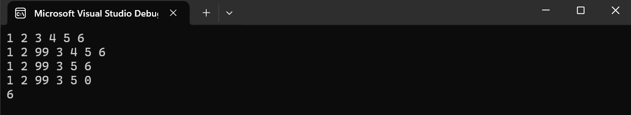
Exercise B — Reverse the Vector
Using only get and set (no extra array), write a loop that reverses the elements of a vector in-place. Hint: swap arr[0] with arr[size-1], arr[1] with arr[size-2], and so on.
MyVector v;
v.push_back(10); v.push_back(20); v.push_back(30);
v.push_back(40); v.push_back(50);
// write your reversal loop here
v.display();

Expected Output:
Vector: 50 40 30 20 10
Code:
#include <iostream>
using namespace std;
class MyVector {
private:
int* arr;
int size;
int capacity;
public:
MyVector() {
capacity = 2;
size = 0;
arr = new int[capacity];
}
void push_back(int value) {
if (size == capacity) {
capacity *= 2;
int* newArr = new int[capacity];
for (int i = 0; i < size; i++) {
newArr[i] = arr[i];
}
delete[] arr;
arr = newArr;
}
arr[size] = value;
size++;
}
void insert(int index, int value) {
if (index < 0 || index > size) {
return;
}
if (size == capacity) {
capacity *= 2;
int* newArr = new int[capacity];
for (int i = 0; i < size; i++) {
newArr[i] = arr[i];
}
delete[] arr;
arr = newArr;
}
for (int i = size; i > index; i--) {
arr[i] = arr[i - 1];
}
arr[index] = value;
size++;
}
void erase(int index) {
if (index < 0 || index >= size) {
return;
}
for (int i = index; i < size - 1; i++) {
arr[i] = arr[i + 1];
}
size--;
}
void set(int index, int value) {
if (index < 0 || index >= size) {
return;
}
arr[index] = value;
}
int get(int index) {
if (index < 0 || index >= size) {
return -1;
}
return arr[index];
}
int getSize() {
return size;
}
void display() {
cout << "Vector: ";
for (int i = 0; i < size; i++) {
cout << arr[i] << " ";
}
cout << endl;
}
~MyVector() {
delete[] arr;
}
};
int main() {
MyVector v;
v.push_back(10);
v.push_back(20);
v.push_back(30);
v.push_back(40);
v.push_back(50);
int n = v.getSize();
for (int i = 0; i < n / 2; i++) {
int temp = v.get(i);
v.set(i, v.get(n - 1 - i));
v.set(n - 1 - i, temp);
}
v.display();
return 0;
}
Output:
